Rocksteady website: I’d like something similar but with a darker green and white as the main colours. Needs to be child friendly.   
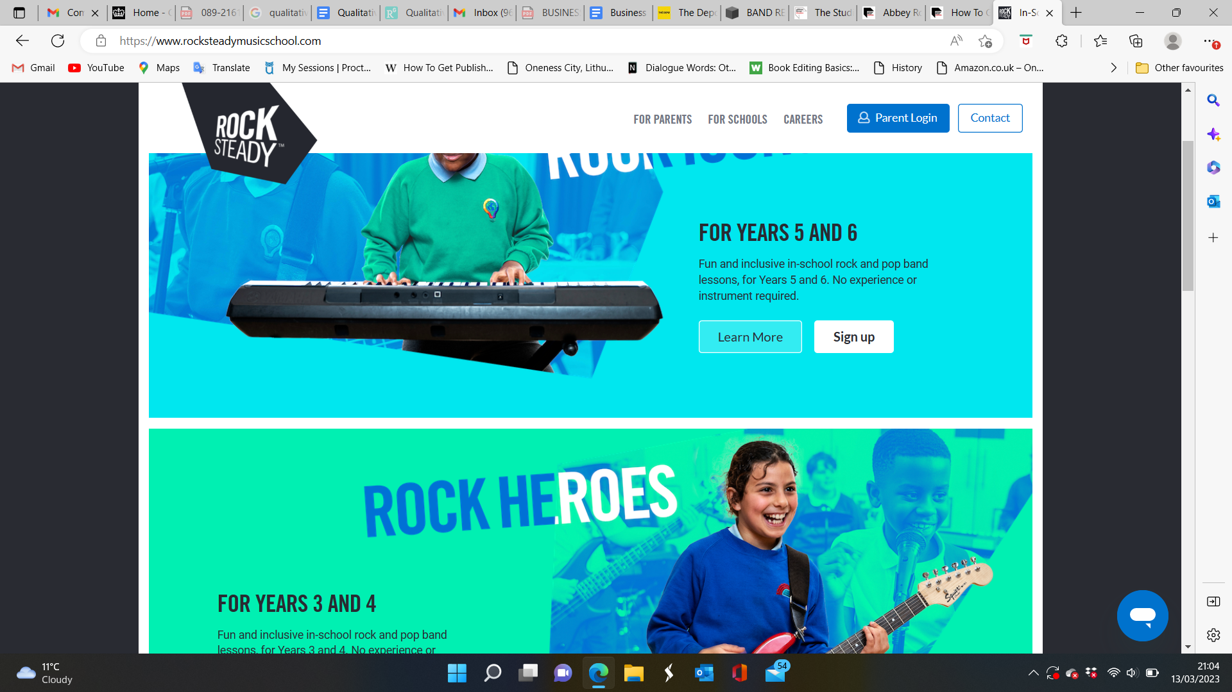





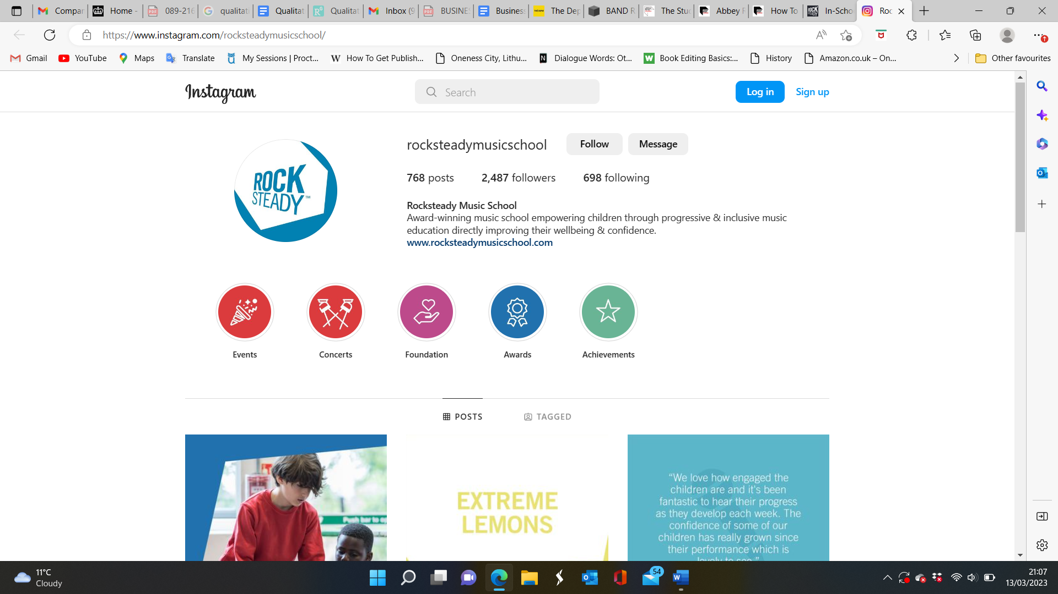

Abbey Road website has this as the main website: All sectors are accessible through the website. However, when clicking on a larger sector such as Abbey Road Institute, it takes you to another website. This is due to the shear amount of information within the Institute sector. The colour themes between the two are different as you can see below: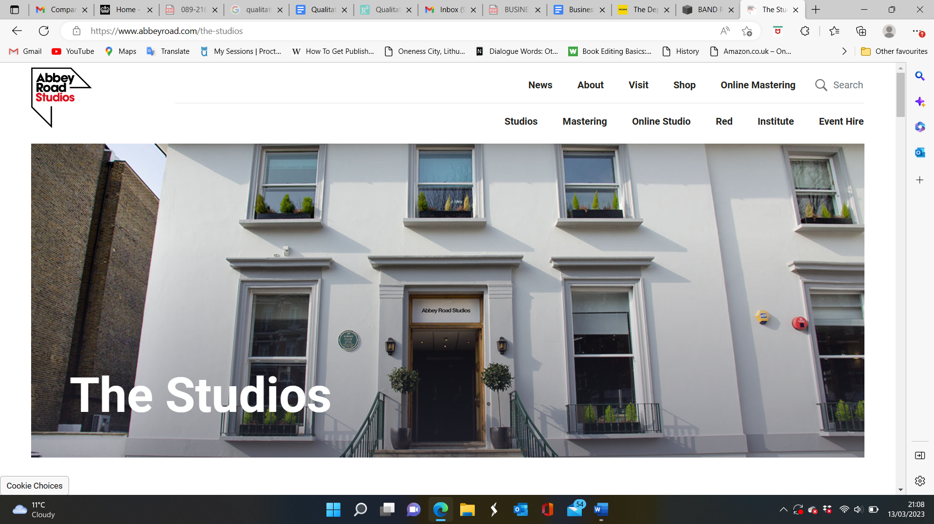

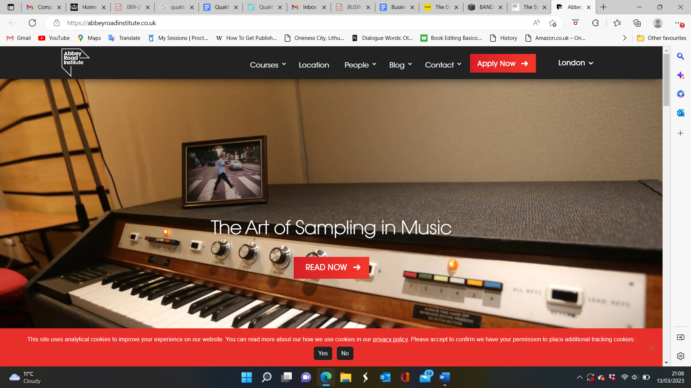

The depo site, Barbican theatre and abbey road all use several quality photos that represent their space and what they do. Due to the location of the studio I would like the studio section of the website to be black and orange themed. This will work well with the Barbican theatre logo.

